

CSC 128 – FUNDAMENTALS OF COMPUTER PROBLEM SOLVING

GROUP: **JCS1101E**

Project Title: **SMART SHOP 2.0**

|  |  |
| --- | --- |
| NAME | MATRIX iD |
| MUHAMMAD HAFIEZUDIN BIN ROSDI | 2017224744 |
| MUHAMMAD AKRAM BIN ISMAIL | 2017233188 |
| MUHAMMAD RAMZI AMRI BIN ROZMI | 2017231946 |
| MUHAMMAD AQIL IRFAN BIN BADRUL HISHAM | 2017258974 |

LECTURER: MADAM NOR FAUZIAH BINTI ABU BAKAR

SUBMISSION DATE: 19 DECEMBER 2017

**Contents**

**Page**

1. **Introduction 3**
   1. **Project Background 3**
   2. **Objectives 4**
   3. **Scope 4**
2. **Program Design 5**
   1. **Program Analysis (IPO Table) 5**

**3.0 Implementation 9**

**3.1 List of Repetition 9**

**3.2 List of Functions 9   
  
4.0 Program Testing 11**

**5.0 Conclusion 15**

**1.0 INTRODUCTION**

This is a report regarding what is a smartphone on its introduction and the purpose of doing smartphone online shopping and how can it be used and what are the advantages and disadvantages of this project and show how this project can change people in buying a smartphone in the future.

As everybody in this modern era knows that smartphone is a device that lets you not only make calls but can do other things as it is has other features and its applications such as email chatting and also video calling which makes it one of the most important things that must have in our life whether to do work or just to have fun in our daily life. According to Wikipedia, the number of smartphone users is forecast to grow from 2.1 billion in 2016 to around 2.5 billion in 2019, with smartphone penetration rates increasing as well. Just over 36 percent of the world's population is projected to use a smartphone by 2018, up from about 10 percent in 2011.

Because of that, we as a team decided to make a business that sells smartphones but in a more advanced way that in by online so then we can show to people how easy to buy smartphones so we built this system with willing to make people do not go out just to buy a smartphone.

**1.1 PROJECT BACKGROUND**

The purpose of this project is to introduce people to our business which we call “Smartshop 2.0” that are scintillating for future.In this business, we provide 2 packages which may attract people to use our system to buy smartphone by online.It also gives people the easier way to buy a smartphone just at their fingertips and does not have to go out.We also selling smartphone such as Samsung Galaxy S8, Samsung Galaxy J7,iPhone6,iPhone8, Oppo R9s, Oppo A37.We also provide a method of delivery which is cash on payment or delivery.

**1.2 OBJECTIVES**

Our objectives that we want to achieve is divided into six objective which is:

i) To get information such as the type of smartphones choose packages and method of payment.

ii) To calculate the price of the smartphone after getting a discount and get free accessories.

iii) To count the number of customers who use the system.

iv) To calculate total income that has received after a customer uses our system.

v) To calculate the total average of the income.

vi) To print information such as price that customer has to pay and what smartphone that customer has chosen and confirmed the information the user address.

**1.3 Project Scope**

As we selling smartphones, we decided to sell this type of smartphone as it has the greatest features and has a great brand which has been known all over the world that is:

|  |  |
| --- | --- |
| Brands | Features |
| Samsung Galaxy S8 | 5.8 inch, 4GB RAM, 12MP f/1.7, 3000 mAh, 64GB |
| Samsung Galaxy J7 | 5.5 inch, 3GB RAM,13MP f/1.7, 3600 mAh, 16GB |
| iPhone 8 | 4.7 inch, 2GB RAM, 12MP f/1.8, 1821 mAh, 64GB |
| iPhone 6 | 4.7 inch, 1GB RAM, 8MP f/2.2, 1810 mAh, 16GB. |
| Oppo R9s | 5.5 inch, 4GB RAM, 16MP f/1.7, 3010 mAh,64GB |
| Oppo A37 | 5.0 inch, 2BG RAM, 8 MP f/2.0, 2630 mAh, 16GB. |

1. **Program Design**

**2.1 Program Analysis (IPO Table)**

|  |  |  |
| --- | --- | --- |
| INPUT | PROCESS | OUTPUT |
| Read Packages  Read TypesOfSmartphone  Read morePackage  Read Answer | While  displayTotal=0  countCustomer=1  Total=0  Module  Choose_Packages(Packages)  If(Packages=="A"|| Packages=="a")  Counter=0  Call SmartphoneSpecification  While  If(TypesOfSmartphone=="A"||TypesOfSmartphone=="a")  Price1= 3389.00  strcpy(Type=”Samsung Galaxy S8”)  Else  If(TypesOfSmartphone=="B"||TypesOfSmartphone=="b")  Price1=1089.00  strcpy(Type=”Samsung Galaxy J7”)  Else  If(TypesOfSmartphone=="C"||TypesOfSmartphone=="c")  Price1=3389.00  strcpy(Type=”iPhone 8”)  Else  If(TypesOfSmartphone=="D"||TypesOfSmartphone=="d")  Price1=1389.00  strcpy(Type=”iPhone 6”)  Else  If(TypesOfSmartphone=="E"||TypesOfSmartphone=="e")  Price1=2989.00  Strcpy(Type=”Oppo R9s”)  Else  If(TypesOfSmartphone=="F"||TypesOfSmartphone=="f")  Price1= 689.00  strcpy(Type=”Oppo A37”)  EndIf  Total=Total + Price1  If(counter=0)  Receipt=Type  Else  TypeReceipt2=Type  If(Counter>=1)  Price=Total * 0.9  Else  Counter= Counter + 1  endWhlie  Else If(Packages=="C" || Packages=="c")  Call SmartphoneSpecification  While  If(TypesOfSmartphone=="A"||TypesOfSmartphone=="a")  Price=3299.00  strcpy(displayPackage=”Samsung Galaxy S8”)  Else  If(TypesOfSmartphone=="B"||TypesOfSmartphone=="b")  Price=999.0  strcpy(displayPackage=”Samsung Galaxy J7”)  Else  If(TypesOfSmartphone=="C"||TypesOfSmartphone=="c")  Price=3299.00  strcpy(displayPackage=”iPhone 8”)  Else  If(TypesOfSmartphone=="D"||TypesOfSmartphone=="d")  Price = 1299.00  strcpy(displayPackage=”iPhone 6”)  Else  If(TypesOfSmartphone=="E"||TypesOfSmartphone=="e")  Price = 2899.00  strcpy(displayPackage=”Oppo R9s”)  Else  If(TypesOfSmartphone=="F"||TypesOfSmartphone=="f")  Price=599.00  strcpy(displayPackage=”Oppo A37”)  EndIf  If(TypesOfSmartphone=="A"||TypesOfSmartphone=="a"||  TypesOfSmartphone=="B"||TypesOfSmartphone=="b"||  TypesOfSmartphone=="C"||TypesOfSmartphone=="c"||  TypesOfSmartphone=="D"||TypesOfSmartphone=="d"||  TypesOfSmartphone=="E"||TypesOfSmartphone=="e"||  TypesOfSmartphone=="F"||TypesOfSmartphone=="f”)  Else  EndWhile  Call Receipt_payment(Packages,TypesOfSmartphone,  displayPackage,TotalLatest,Price)  If(morePackage=="N"||morePackage=="n")  Call PaymentMethod  Total_Latest=0  If(Packages=="A"||Packages=="a")  Total_Latest=Total_Latest + Price  displayTotal=displayTotal + TotalLatest  If(Answer=="N"||Answer=="n")  Else  countCustomer=countCustomer + 1  EndIf  EndWhile | Display "WELCOME TO SMART SHOP 2.0"  Module  Choose_Packages(Packages)  Display "-------------------------------------------------------------------------------------------------------------------------"  Display "| Packages | Details | "  Display "-------------------------------------------------------------------------------------------------------------------------"  Display "| PackageA | >Buy 2 smartphones ,a screen protector privacy worth RM60 |"  Display "| | >A phone casing worth RM30 for each smartphone will get 10% less from the total price |"  Display "| | >10000 mAh powerbank worth RM65 |"  Display "|--------------|----------------------------------------------------------------------------------------------------------|"  Display "| PackageC | >Buy 1 smartphone and get a screen protector worth RM50 |"  Display "| | >A phone casing worth RM30 as a free gift |"  Display "-------------------------------------------------------------------------------------------------------------------------"  Display "Please choose your packages[A,C]"  Return  module  SmartphoneSpecicfication  Display "Samsung Galaxy S8 specifications: RM3299, 5.8 inch, 4GB RAM, 12MP f/1.7,3000 mAh, 64GB"  Display "Samsung Galaxy J7 specifications: RM999, 5.5 inch, 3GB RAM, 13MP f/1.7, 3600 mAh, 16GB"  Display "iPhone 8 specifications: RM3299, 4.7 inch, 3GB RAM, 12MP f/1.8, 1821 mAh, 64GB"  Display "iPhone 6 specifications: RM1299, 4.7 inch, 1GB RAM, 8MP f/2.2, 1810 mAh, 16GB"  Display "Oppo R9s specifications: RM2899, 5.5 inch, 4GB RAM, 16MP f/1.7, 3010 mAh, 64GB"  Display "Oppo A37 specifications: RM599, 5.0 inch, 2GB RAM, 8MP f/2.0, 2630 mAh, 16GB"  Return  Display "Choose type of smartphones[A-SamsungS8,B-SamsungJ7,C-iPhone8,D-iPhone6,E-OppoR9s,F-OppoA37] : "  Display "Wrong code!"  Display "Choose type of smartphones[A-SamsungS8,B-SamsungJ7,C-iPhone8,D-iPhone6,E-OppoR9s,F-OppoA37] : "  Display "Wrong code!"  Display "Your first smartphone is ", TypeReceipt, " and second smartphone is ",TypeReceipt2,displayPackage  Display "Choose your second smartphone"  Display"Buy more package?[Y/N] : "  module  Receipt_payment  Display "********************************"  Display "Your package : ", Packages  Display ’””,displayPackage  Display "Your smartphone : ", displayPackage  Display "Your total is : RM", Total_Latest  Display "********************************"  Display "Final total price : RM", Total_Latest  Display "Do you want to enter another visitor information? [y or Y:Yes] "  Display "YOUR TOTAL CUSTOMER : ", countCustomer  Display "TOTAL PAYMENT RECEIVED : ", displayTotal  Display “The average of income per customer is : RM", displayTotal/countCustomer; |

**3.0 Implementation**

There are implementations that we insert into our system that is repetition and function.

**3.1 List of repetition**

|  |  |
| --- | --- |
| Loop | Function |
| first | to loop the number of customers who use our system so we can know how many people using our system |
| second | to loop the packages if the user chooses to take more than 1 packages so the user can buy more smartphones |
| Third&fourth | the user to choose smartphones and after the user input the first smartphone the system will ask the user again to input the other smartphone if the user wants to choose other smartphones. |
| fifth | the user to choose smartphones and after the user input the first smartphone the system will ask the user again to input the other smartphone if the user wants to choose other smartphones. |
| sixth | the user to choose smartphones and after the user input the first smartphone the system will ask the user again to input the other smartphone if the user wants to choose other smartphones. |

**3.2 List of function**

In this system, we basically have 4 functions in this system which is function_packages, SmartphoneSpecification, Receipt_payment and paymentMethod.

|  |  |
| --- | --- |
| Function | Description |
| Choose_Packages | is to ask the user to input which packages that the user wants which is packages A or packages C and tells to the user what is the content in each package so the user can choose their packages that they wanted to choose. |
| SmartphoneSpecification | to display to the user the specification of each smartphone that we selling so the user know what smartphone that has attracted their heart because of the features of each smartphone. |
| Receipt_Payment | to print the receipt payment as the user already buy the smartphones and act as providence so the user already buys the smartphone if there any problems happen. |
| PaymentMethod | act to ask user which method to use to make payment after choosing packages and choose your smartphones which divided into 2 which is Cash On Delivery that only available in Segamat area or pickup at 1 Shopping Complex, First Floor,,Jalan Kolam Air, Kampung Gubah, 85000 Segamat District, Johor, Malaysia or payment by bank in which ask user to input user’s name and address so the system can identify the user’s identity after user inserted the money in the bank and can deliver the smartphone safely to its destination. |

**4.0 Program Testing**

As to show the success of the system we will include 3 input to show the result of the output

1.  
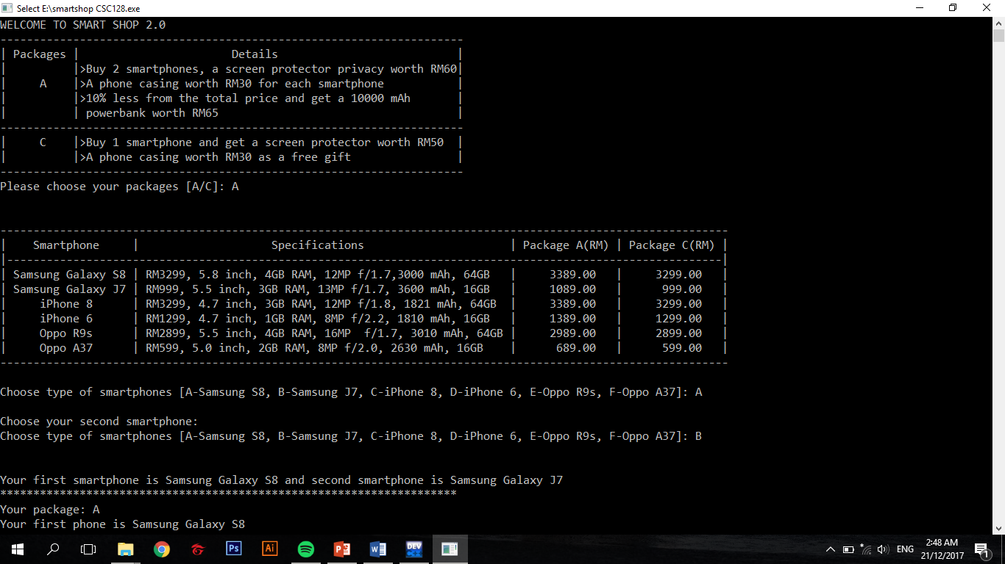

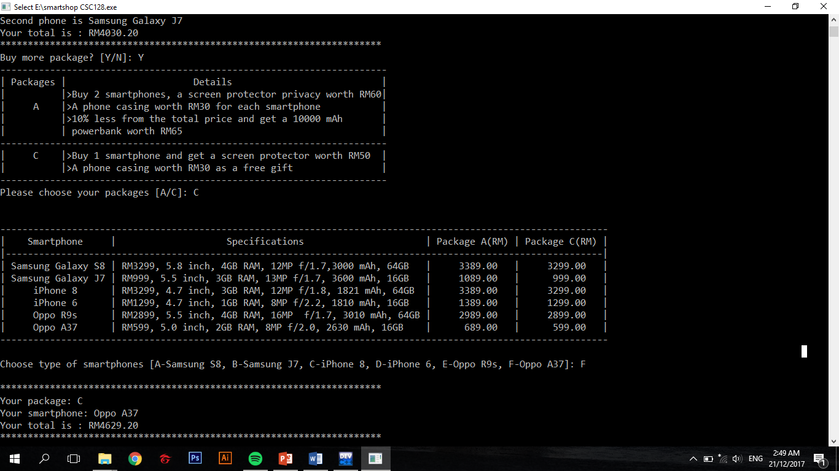

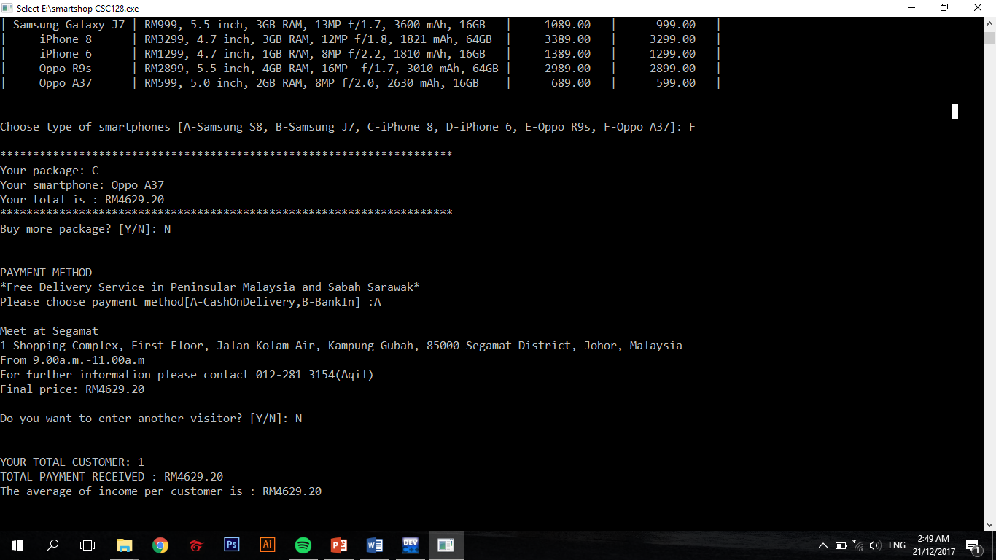

2.  
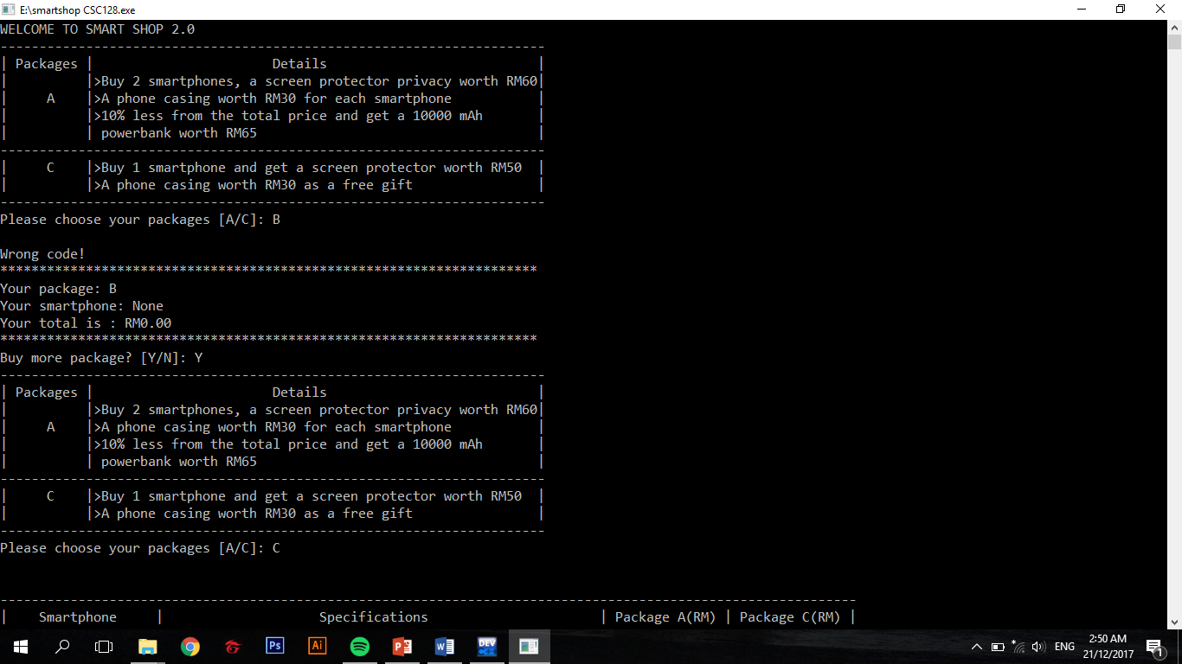

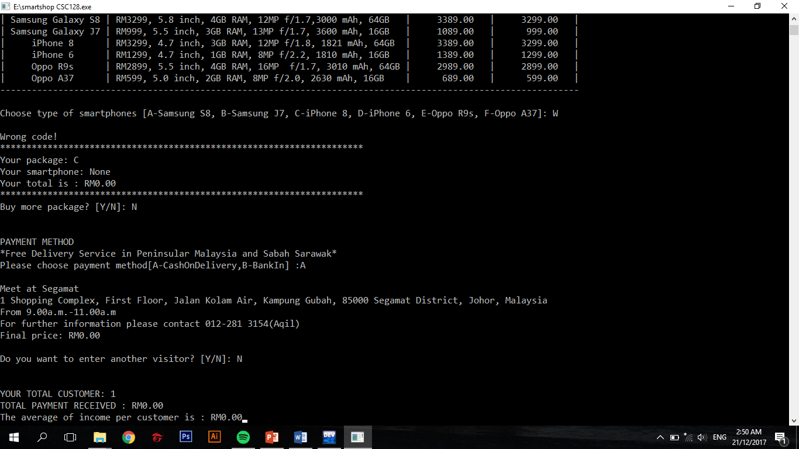

3.  
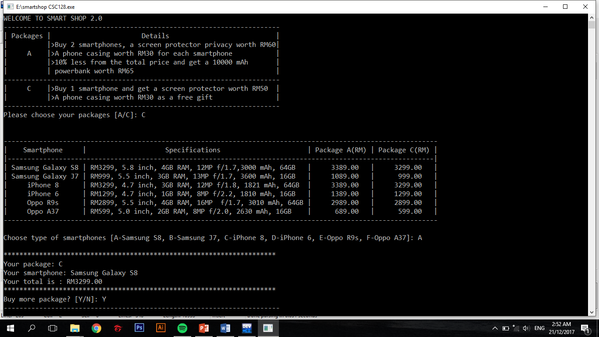

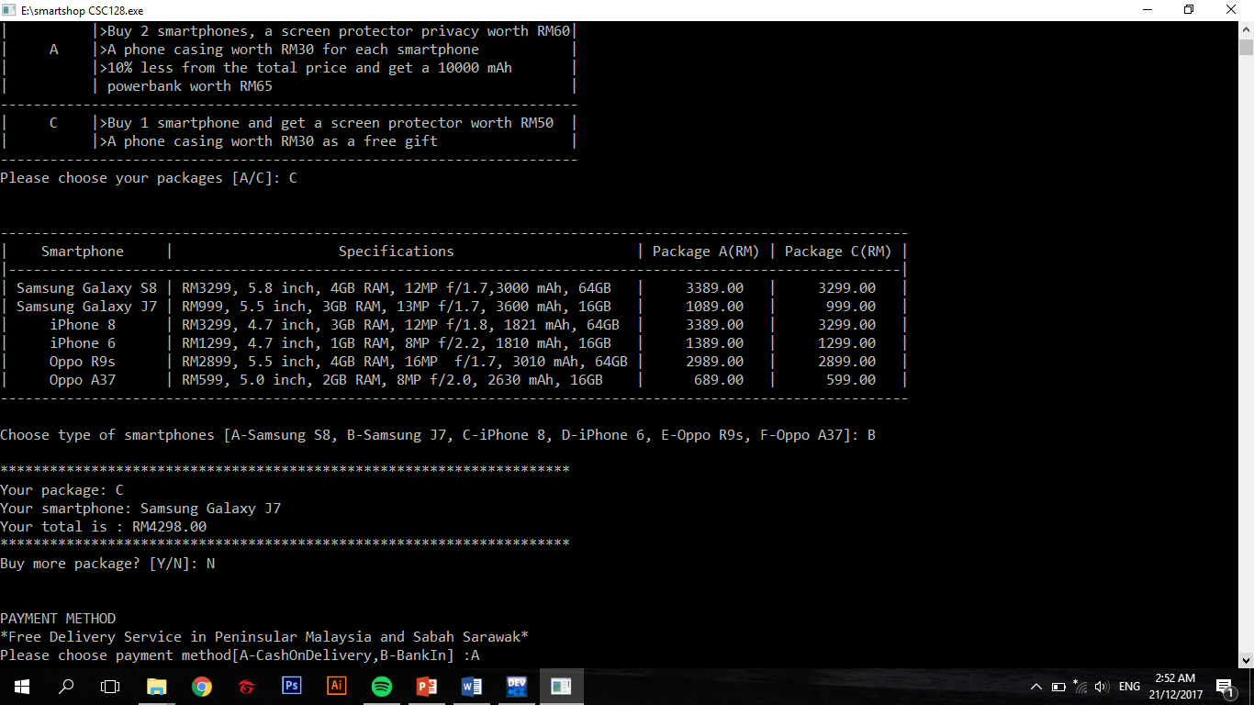

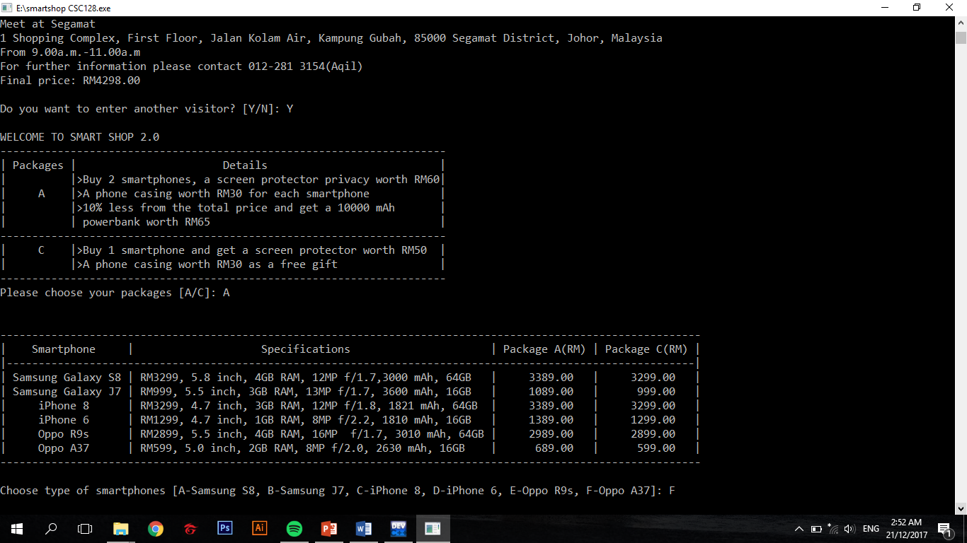

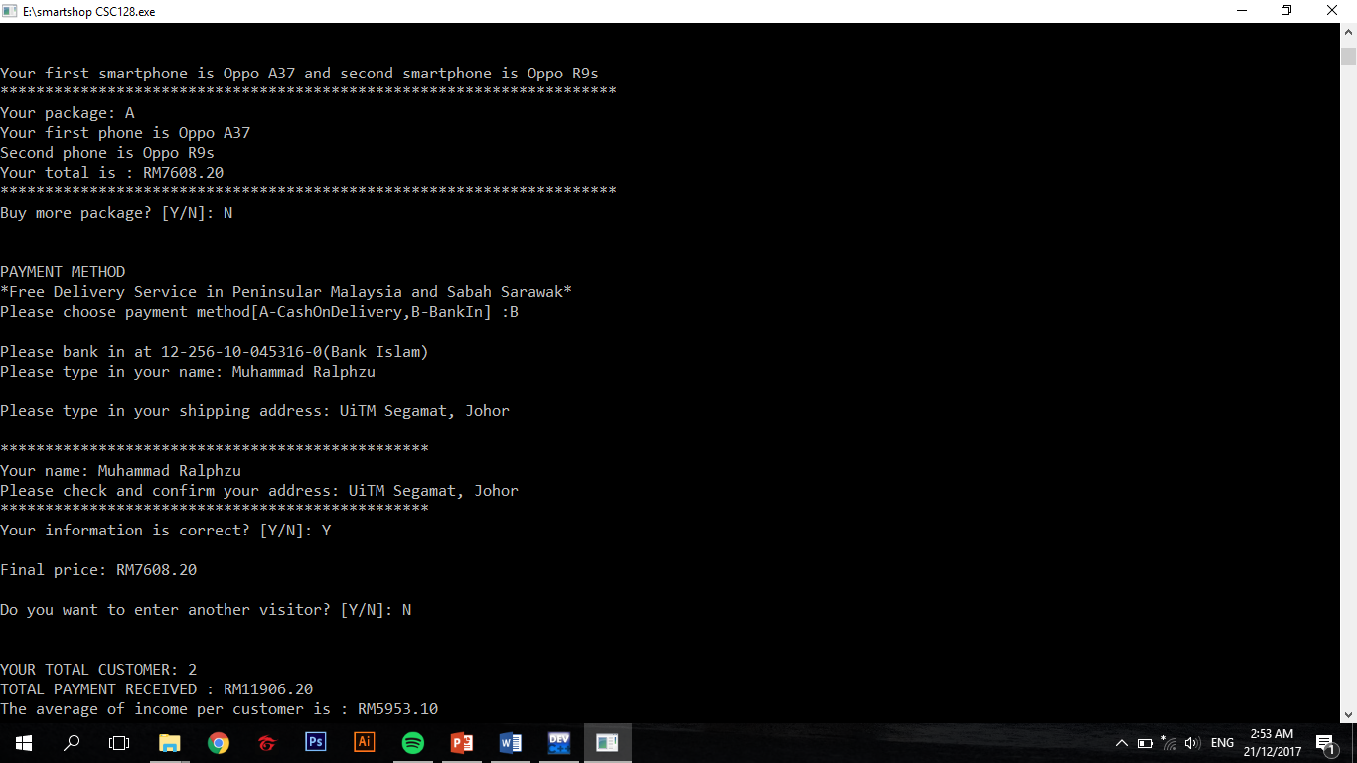

**5.0 Conclusion**

We hope that this system will help people buy smartphones easier and get cheaper price than buying at a retail shop that doesn’t give any free gifts and discounts.